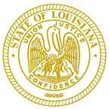
Louisiana State Board of
Electrolysis Examiners

CHAIRMAN

John Bel Edwards

GOVERNOR

Kyle Ardoin

SECRETARY

Tonya Freeman Julie Bennett Dr. Nicole Rogers
SECRETARY TREASURER PHYSICIAN

OPEN BOARD MEETING

DATE & TIME Monday, December 6, 2021@ 3:30 p.m.

LOCATION 3100 Galleria Dr. Suite 201
Metairie, La.70001

AGENDA CALL TO ORDER
ROLL CALL
PUBLIC INPUT (3 MIN)
READING OF THE MINUTES
READING FROM TREASUER
REPORT FROM BOARD MEMBERS

BUSINESS FROM THE FLOOR:

NEXT MEETING DATE:

ADJOURMENT

